Systems Analysis and Testing  
Comp 2147   
Professor: Abid Rana

Group Project:  
ABC Clinic

**David Fortich (101314570)**

**Jorrel Tigbayan (101329925)  
Dennis Varghese (101020193)**

**Michael Noseworthy (????)  
Nate ???? (????)**

**Mustafa Banduka (????)**

George Brown College

# TABLE OF CONTENTS

Question 1: System Service Request

Question 2: Project Charter

Question 3: Feasibility Analysis

Question 4: Textual Analysis and Use Case Diagram (first cut)

Question 5: Kite Level Written Use Case Diagrams

Question 6: Activity Diagrams

Question 7: Refined Use Case Diagram

Question 8: Context level Data Flow Diagram

Question 9: Level 0 Data Flow Diagram

Question 10: Decision Table

Question 11: BPMN Diagram

Question 12: Conceptual Data Model

Question 13: Logical Data Model

Question 14: Class Diagram

Question 15: Wireframes

Question 16: Dialogue Diagram

Question 17: Testing Strategy

# 

# Question 1: System Service Request

# Question 2: Project Charter

# Question 3: Feasibility Analysis

# 

# 

# Question 4: Textual Analysis and Use Case Diagram (first cut)

# 

# Question 5: Kite Level Written Use Case Diagrams

|  |
| --- |
| **Use Case Title:** Recall Patient |
| **Primary Actor:** Receptionist |
| **Level:** Kite (summary) |
| **Stakeholders:** Patient, Doctor, Laboratory |
| **Precondition:** Lab tests ordered for a patient |
| **Minimal Guarantee:** Message sent to patient and recorded on system |
| **Success Guarantees:** Patient sets appointment to discuss results |
| **Trigger:** Abnormal lab tests received by clinic |
| **Main Success Scenario:**   * 1. Lab Tests received and recorded into system   2. Lab Test logged as abnormal by nurse or physician   3. Note set to contact patient   4. Patient is called   5. Patient schedules appointment   6. Doctor discusses results with patient |
| **Extensions:**  1a. Results are not received  1a1. Scheduled reminder for clinic to check in on lab results.  1a1a. Clinic contacts lab, results are received.  1a2. Patient inquires about results.  1a2a. Clinic contacts lab, results are received.  1b. Results cannot be recorded.  1b1. Results are saved physically until they can be uploaded to system.  1b2. Results are changed to a format in which they can be recorded.  2a. Abnormal lab log not saved on system.  2a1. Scheduled reminder for receptionist to check in with nurse on results received.  2a1a. Patient called after check in with nurse.  3a. Note not set.  3a1. Scheduled reminder for receptionist to check in with nurse on results received.  3a1a. Patient called after check in with nurse.  3b. Note not checked.  3b1. Scheduled reminder for receptionist to check call notes.  3b1a. Patient called.  4a. Patient does not answer call.  4a1. Patient called again at a later time.  4a1a. Patient messaged through text / email. Call and message recorded.  5a. Patient does not wish to schedule by phone at that moment.  5a1. Patient can schedule online  5a2. Patient can call back later  5a3. Patient can walk-in  6a. Patient does not show for appointment  6a1. Patient is fined.  6a2. Patient is called back for new appointment |

|  |
| --- |
| **Use Case Title:** Note Patient Data |
| **Primary Actor:** Nurse |
| **Level:** Kite (summary) |
| **Stakeholders:** Patient, Nurse, Doctor |
| **Precondition:** Patient arrives for appointment / walk-in |
| **Minimal Guarantee:** Patient data is saved to system |
| **Success Guarantees:** Patient data is used by doctor to aid diagnosis / treatment |
| **Trigger:** Patient is seen by nurse for triage |
| **Main Success Scenario:**   * 1. Patient is seen by nurse   2. Patient information is taken   3. Patient data is entered into system   4. Patient data is used by doctor at appointment   5. Doctor arrives at diagnosis or treatment |
| **Extensions:**  1a. Patient no-show for appointment / leaves before triage  1a1. Patient is contacted to check-in on their well-being.  1a2. Appointment cancelled and physician notified.  2a. Patient information cannot be taken  2a1. Reason for exception is entered to system and either sent to doctor or to hospital  3a. Patient data cannot be entered to system.  3a1. Local copy of data is kept until it can be uploaded to system.  3b. Patient data is entered with errors.  3b. Physician, or nurse make corrections when error is discovered.  4a. Patient data is not received by physician  4a1. Physician contacts nurse to obtain information.  4a2. Physician retakes basic information during appointment.  5a. Doctor is unable to reach a diagnosis.  5a1. Requisition or referral is made. |

# Question 6: Activity Diagrams

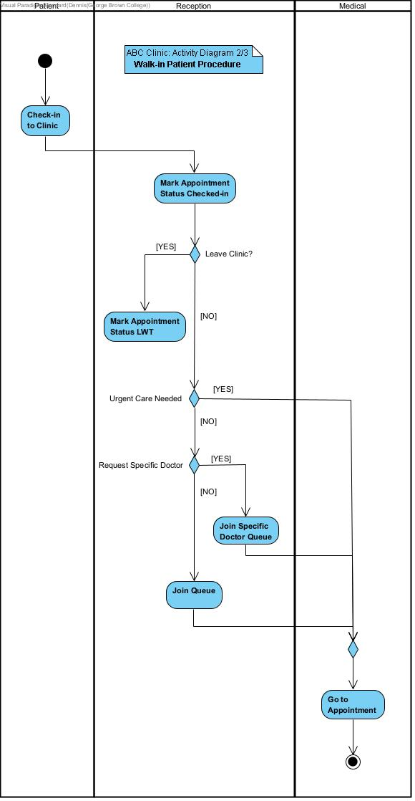

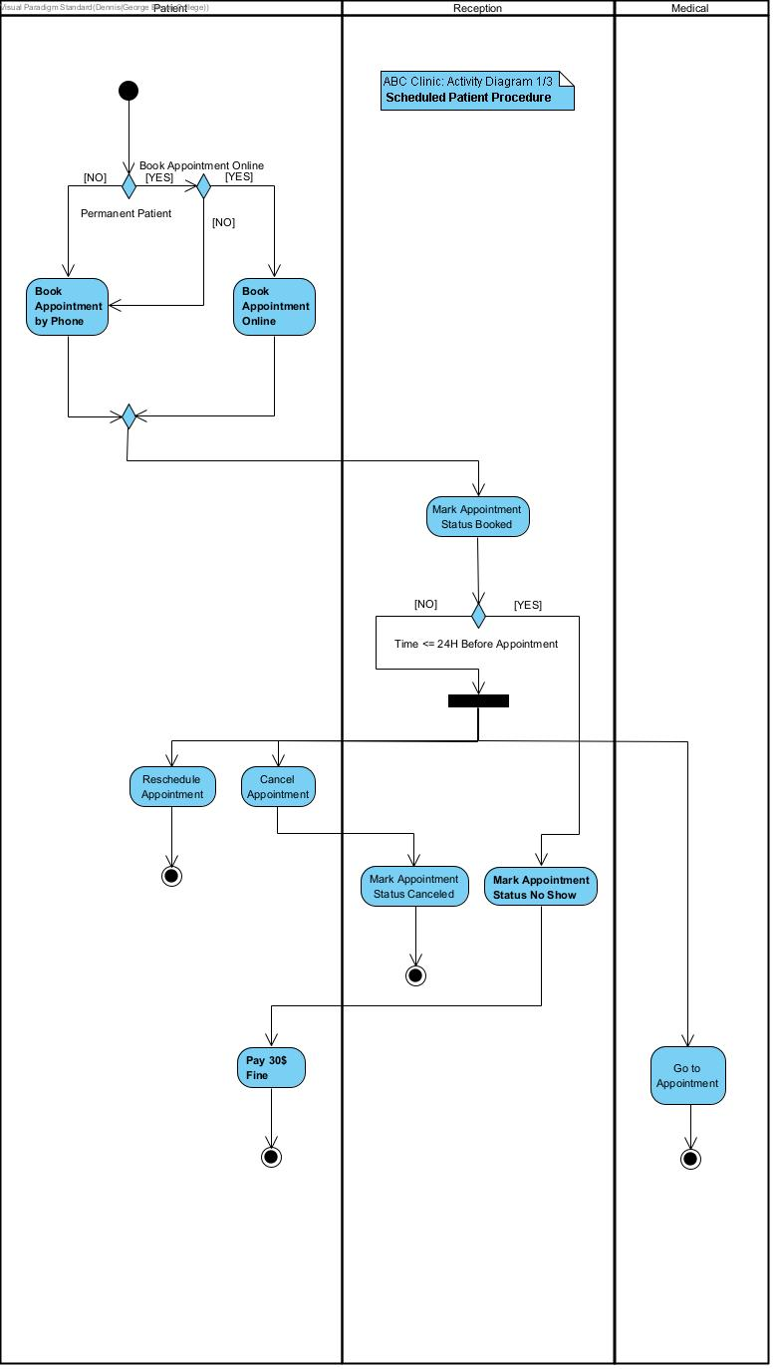

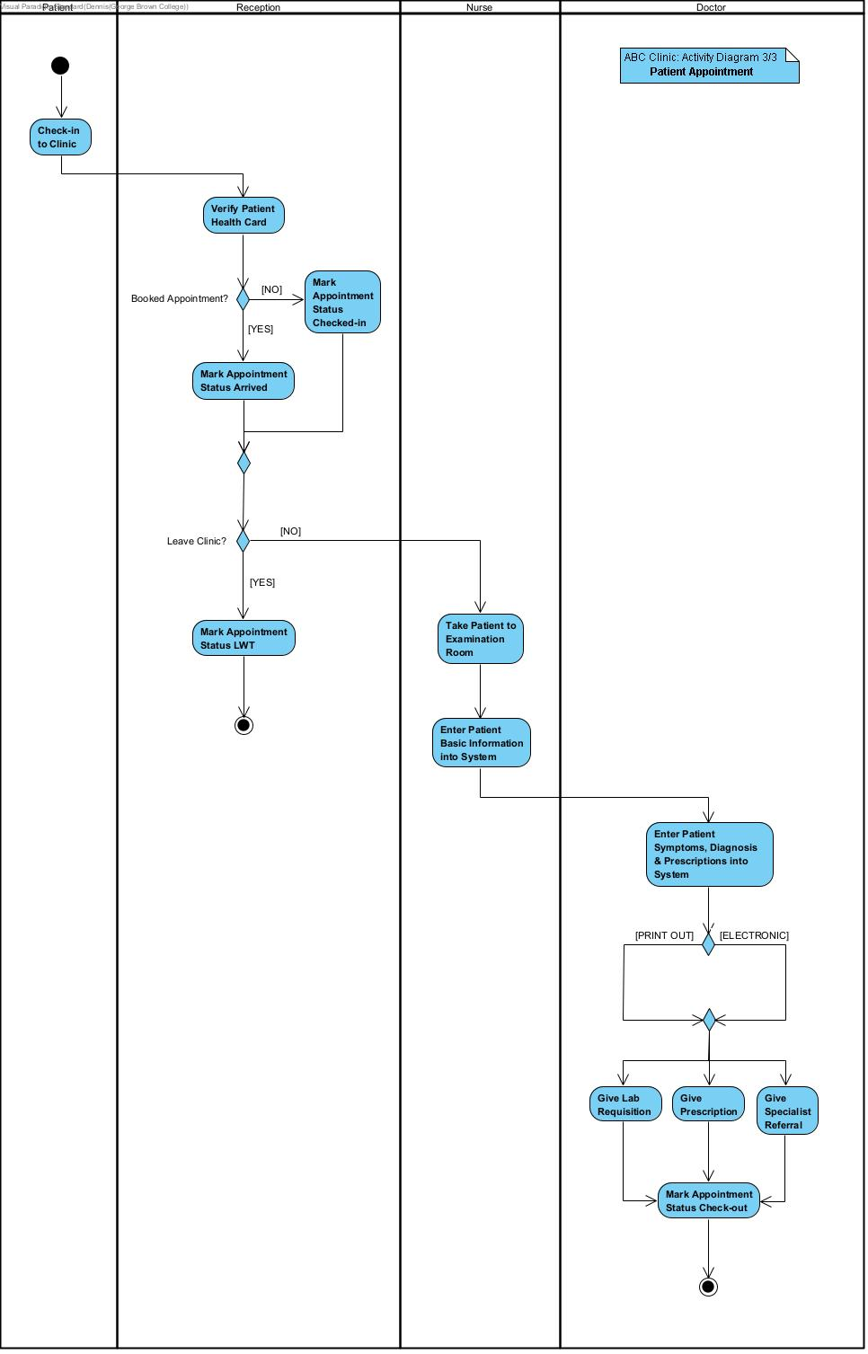

# 

# Question 7: Refined Use Case Diagram

# Question 8: Context level Data Flow Diagram

# Question 9: Level 0 Data Flow Diagram

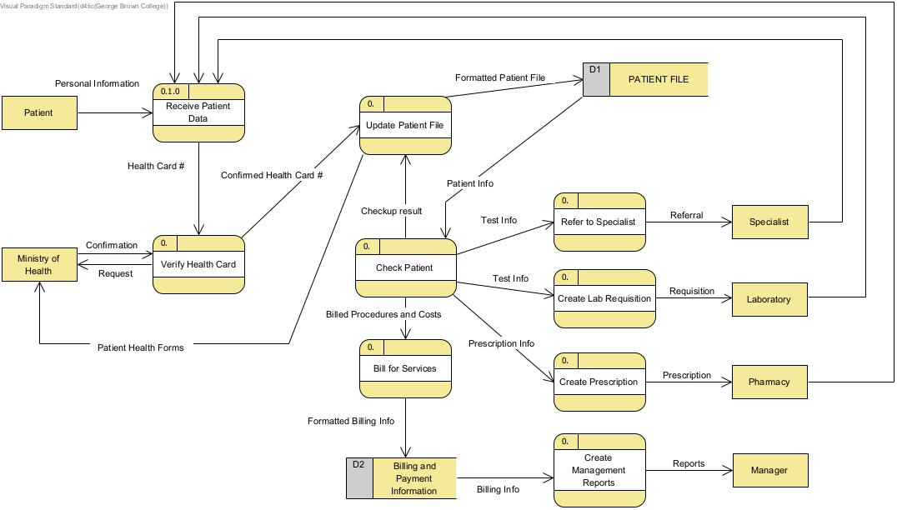

# Question 10: Decision Table

# Question 11: BPMN Diagram

# Question 12: Conceptual Data Model

# Question 13: Logical Data Model

# Question 14: Class Diagram

# 

# 

# Question 15: Wireframes

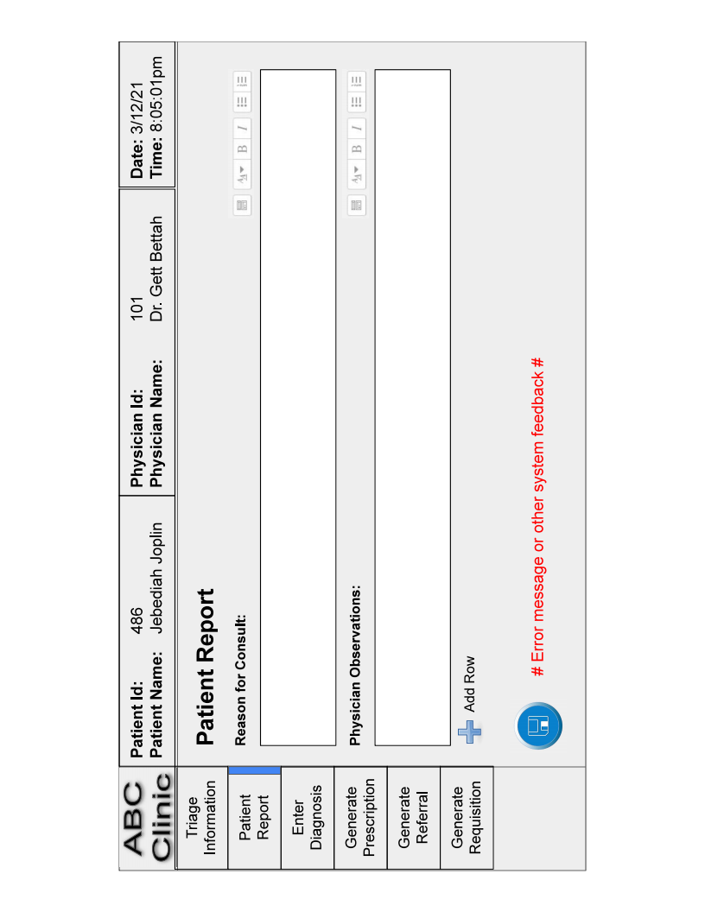

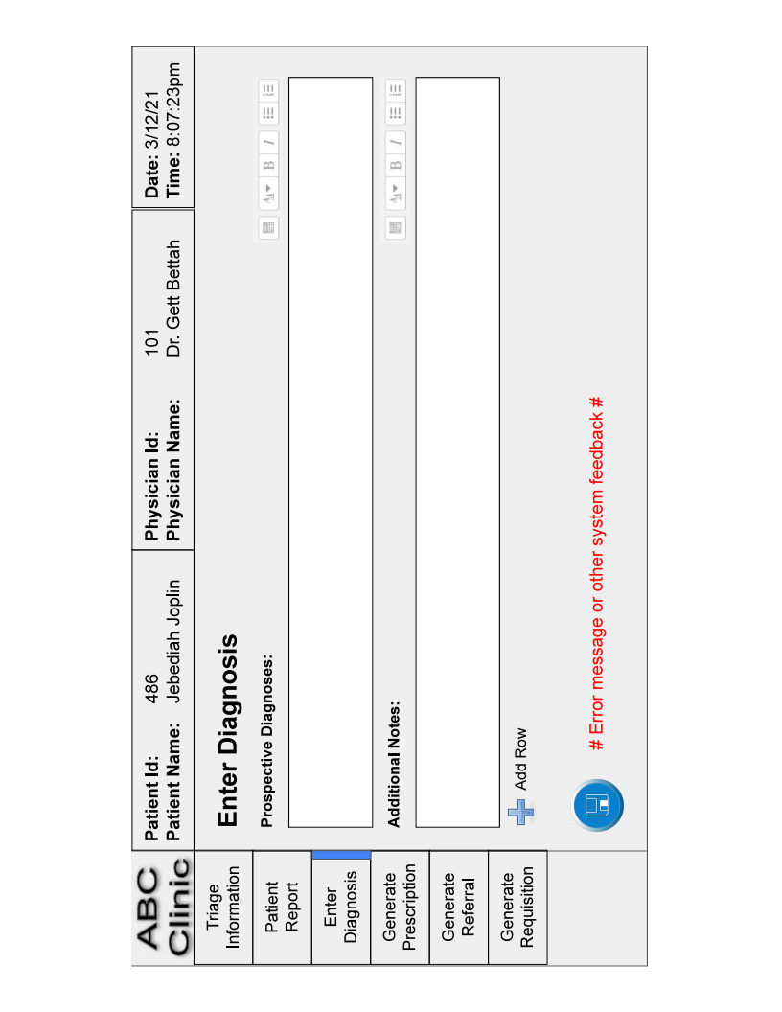

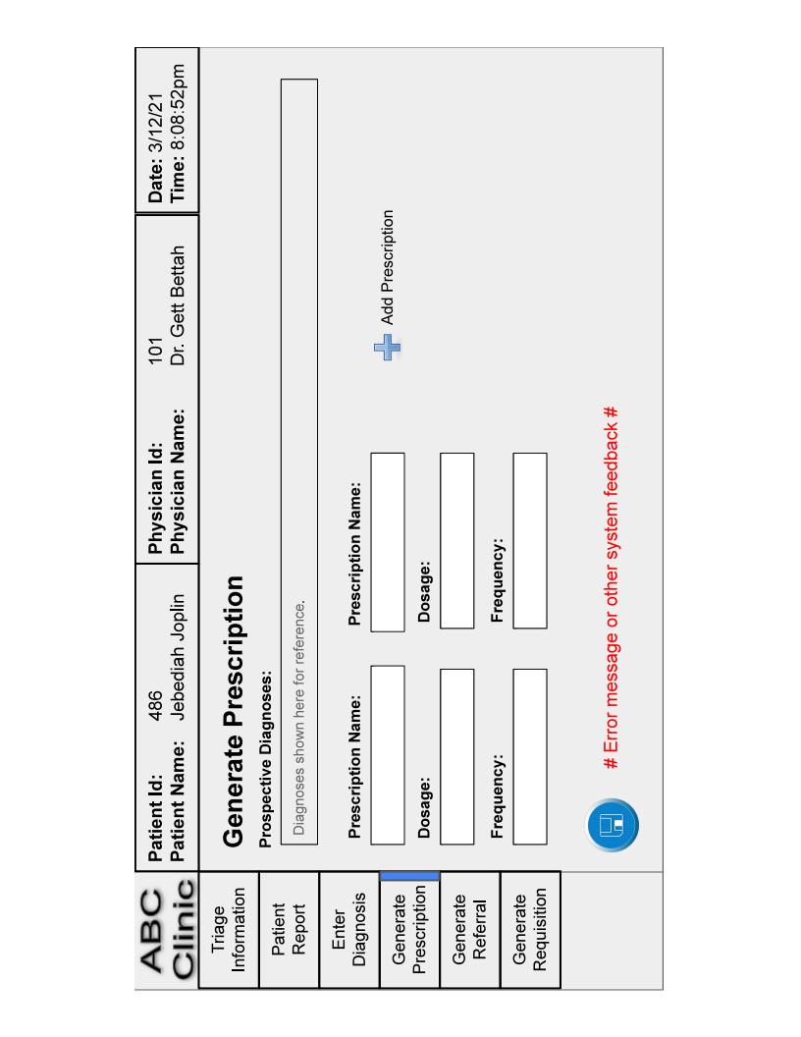

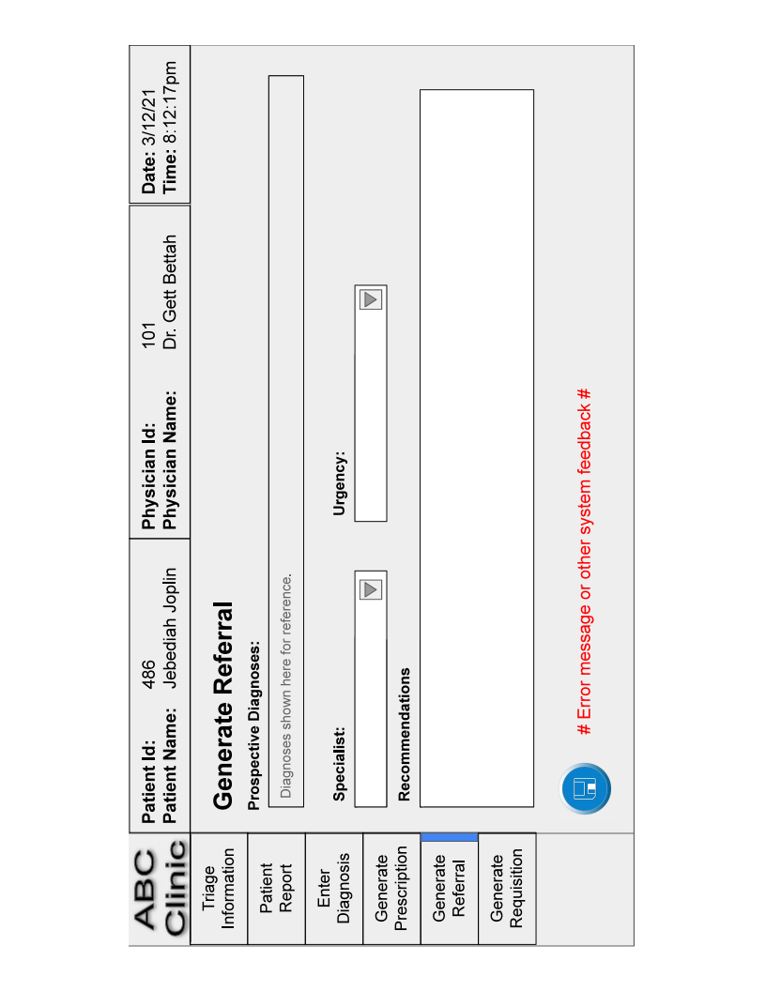

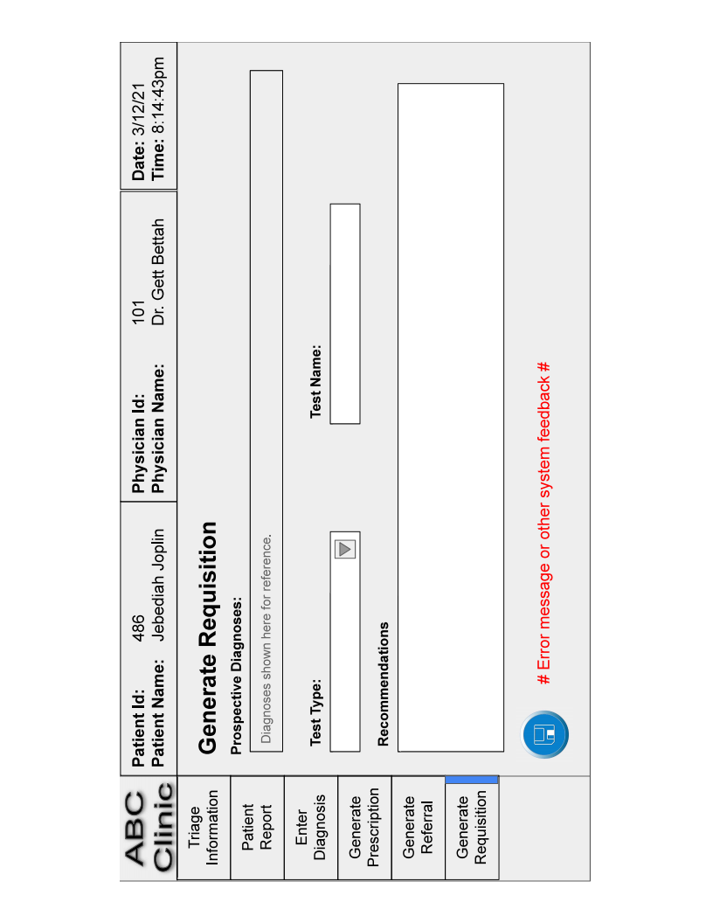

# Question 16: Dialogue Diagram

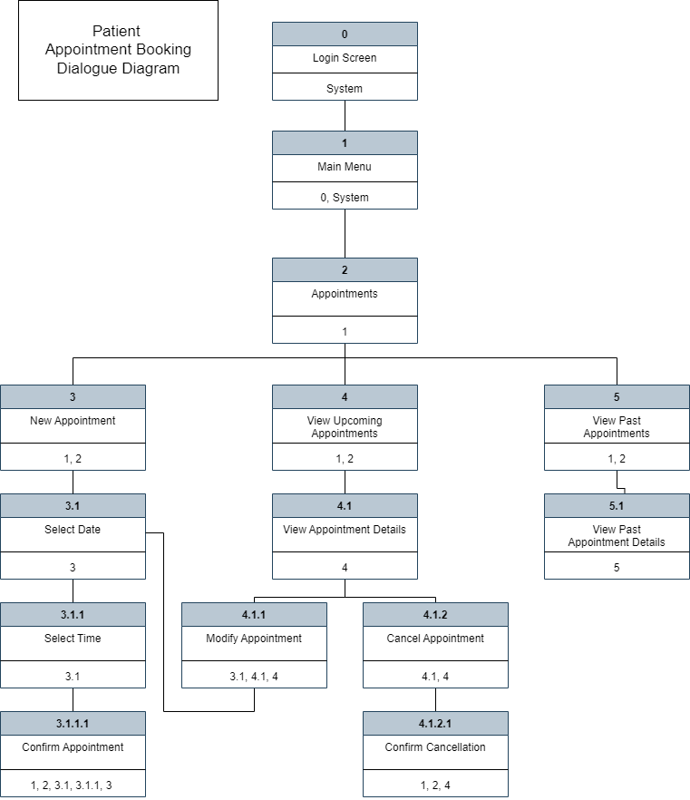

# Question 17: Testing Strategy

The basics testing strategies for the system and type of test and its process.

Computer programs will never work if they are not thoroughly and fully tested. The following range of testing methodologies including white box, black box, static and dynamic. the stages from planning to acceptance of testing.

The purpose of testing is to confirm that the system satisfies requirements

Testing must be planned

**Software application testing** is done during the designing the system and integration test plan. It’s cover several types of ; static testing code executed and tested. It can be done manually inspection , automated, unit, integration and system test.

Master test plan is developed during the analysis phase

•During the design phase, unit, system and integration test plans are developed

•The actual testing is done during implementation

•Written test plans provide improved communication among all parties involved in testing

**Desk checking**– testing technique in which the program code is sequentially executed manually by the reviewer

**Unit testing** – process of testing each module alone in an attempt to discover any errors in its code

**Integration testing** – process of bringing together all of the modules that a program comprises for testing purposes. Modules are typically integrated in a top-down, incremental fashion.

**System testing** – bringing together of all of the programs that a system comprises for testing purposes. Programs are typically integrated in a top-down, incremental fashion.

.**Stub testing** – technique used in testing modules, especially where modules are written and tested in a top-down fashion, where a few lines of code are used to substitute for subordinate modules